# Scenario #: Bug 2: Loan limit is not enforced

## Scenario Description

* Replicate Bug 2

## Version Control

|  |  |  |  |
| --- | --- | --- | --- |
| Version # | Date | Author | Description |
| 1187ba66d2e1f7129da3382fb9fddd56c54d2577 | 16/10/2006 | Toby Sriratanakkoul | [Bug2 FAT Run H1 - True](https://github.com/TitanSri/ITC205---A4/commit/1187ba66d2e1f7129da3382fb9fddd56c54d2577) |
| 7f1e3cc62792b6198dd1cbec5d9f47ec7521a0ca | 16/10/2006 | Toby Sriratanakkoul | [Bug2 FAT Run H2 - True](https://github.com/TitanSri/ITC205---A4/commit/7f1e3cc62792b6198dd1cbec5d9f47ec7521a0ca) |
| 8bb552932535cb2880cbb55f76660133ac8ce26b | 16/10/2006 | Toby Sriratanakkoul | [Bug2 FAT Run H3 - True](https://github.com/TitanSri/ITC205---A4/commit/8bb552932535cb2880cbb55f76660133ac8ce26b) |
| 15cca439fc9f3d1af1e6ba11cc82e95ea760bf41 | 16/10/2006 | Toby Sriratanakkoul | [Bug2 FAT Run H4 - True](https://github.com/TitanSri/ITC205---A4/commit/15cca439fc9f3d1af1e6ba11cc82e95ea760bf41) |
| 9d59c4ee14034535a612017dc588554186cdab17 | 16/10/2006 | Toby Sriratanakkoul | [Bug2 FAT Run H5(un do previous H5) - True](https://github.com/TitanSri/ITC205---A4/commit/9d59c4ee14034535a612017dc588554186cdab17) |
| a5c7a0eef7c5c39e6c8b93a806481e1f3e33db48 | 16/10/2006 | Toby Sriratanakkoul | [Bug2 FAT Run H6 - True](https://github.com/TitanSri/ITC205---A4/commit/a5c7a0eef7c5c39e6c8b93a806481e1f3e33db48) |
| 922212ef3ef98159796b523327f2b23b50c5f3cd | 16/10/2006 | Toby Sriratanakkoul | [Bug2 FAT Run H7 - True](https://github.com/TitanSri/ITC205---A4/commit/922212ef3ef98159796b523327f2b23b50c5f3cd) |

## Test Scripts

The following scripts will cover this scenario:

* 1.1 Replicate Bug 2

## Use Case

* Borrow Item – When a item limit is 2

## Test Components/Requirements

This test scenario covers the following high-level test requirements (see scripts below for specific requirements covered by each test script):

* Need a patron with current loan
* Need 5 items associated with the loan
* Borrow more than two items

## Script #: Replicate Bug 1

### Script Description

* Given two or more items borrowed

### Testing Objective

* When two items is borrow than a third is not possible

### Setup

* Create a patron with two borrowing restrictions
* Create available items
* Make the patron borrow more than two items

### Test Data

|  |  |
| --- | --- |
| Data | Value |
| Patron | Ln: t, Fn: j, Em: jt, PHno: 1 |
| Book Id | A: a, T: t, CNo: 1 |
| DVD Id | A: d, T: v, CNo: 2 |
| VHS Id | A: v, T: h, CNo: 3 |
| CD Audio disk Id | A: c, T: d, CNo: 4 |
| Audio Cassette Id | A: a, T: c, CNo: 5 |

### Teardown

* Reset patron to no loans, no fines
* Reset book to available
* (Remove library.obj file, and rebuild library from scratch)

### Script Steps

| **Step #** | **Test Action** | **Expected Results** | **Pass/ Fail** |
| --- | --- | --- | --- |
| 1 | Enter ‘B’ to borrow an item | Borrow Item Use Case UI title and “Swipe patron card” prompt | P |
| 2 | Enter “1” for patron id | “Scan Item” prompt | P |
| 3 | Enter ‘1’ for book | “Scan Item” prompt | P |
| 4 | Enter ‘2’ for dvd | “Loan limit reached” | F |

### Test Execution

|  |  |  |  |  |
| --- | --- | --- | --- | --- |
| Date/Time | Tester | Test ID | Test Phase | Status |
| 16/10/22 | Toby Srira | Tsrira01 | System Cycle 1 | Failed |
| 16/10/22 | Toby Srira | Tsrira01 | System Cycle 1 | Passed |

Run 1 results:

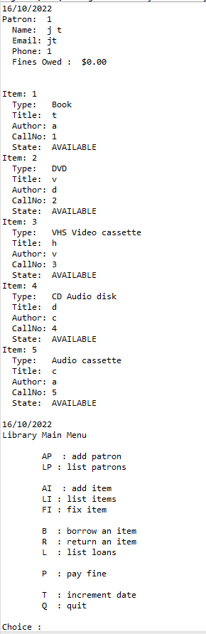

Step 1

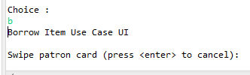

Step 2



Step 3

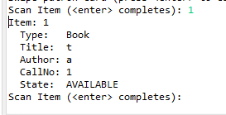

Step 4

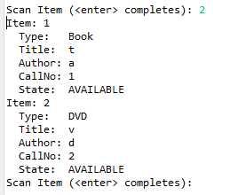

Should display a limit message, however if you press 3 then you can see the message

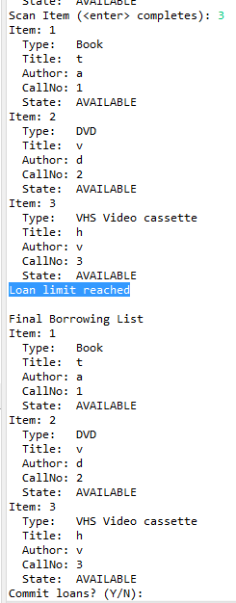

Bug2 bug log:

**Simplification (observed)**

H1: Everything is all right until the end of borrow item 2.

T1: Inspect code for end of borrow item 2.

R1: The user can keep borrow 3 items.

H1: True

Commit logs:

<https://github.com/TitanSri/ITC205---A4/commit/1187ba66d2e1f7129da3382fb9fddd56c54d2577>

**Tracing**

H2: There is no restriction

T2: Inspect code for restriction in BorrowItemControl>itemScanned();

R2: library.getNumberOfLoansRemiangForPatron(); line 79 is returning 0

H2: True

Number of loans remain is still 2 after an item is already scanned.

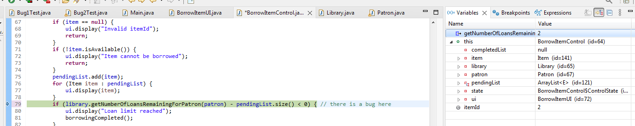

Commit logs:

<https://github.com/TitanSri/ITC205---A4/commit/7f1e3cc62792b6198dd1cbec5d9f47ec7521a0ca>

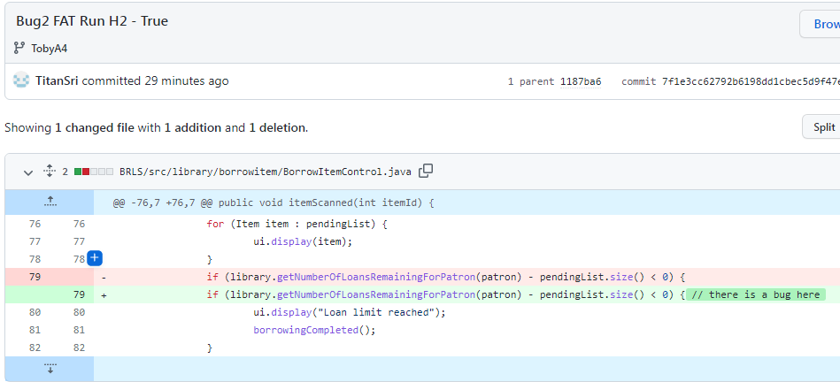

H3: The limit is activated after 3 items

T3: Inspect code for restriction in BorrowItemControl>itemScanned();

R3: library.getNumberOfLoansRemiangForPatron() – pendingList.sze() < 0; line 79 is returning 0, however 0 – 3 equals -1

H3: True, the code should be <= to zero and not <

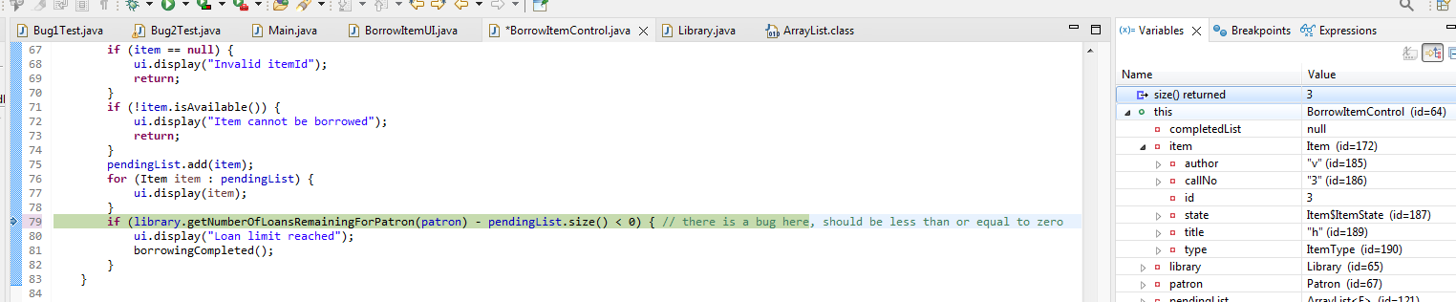

Commit Logs:

<https://github.com/TitanSri/ITC205---A4/commit/8bb552932535cb2880cbb55f76660133ac8ce26b>

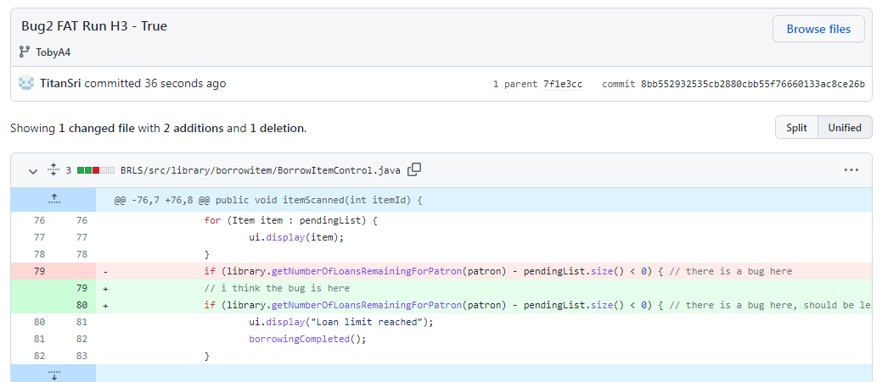

H4: After the Loan limit is reached, the system still asks the user to commit the loan

T4: Inspect BorrowItemUI

R4: BorrowItemsUI; line 85

H4: True,

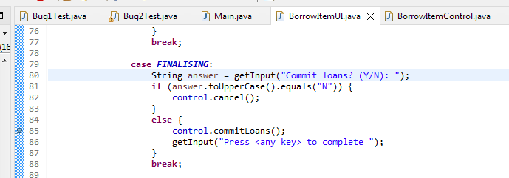

Commit logs:

<https://github.com/TitanSri/ITC205---A4/commit/15cca439fc9f3d1af1e6ba11cc82e95ea760bf41>

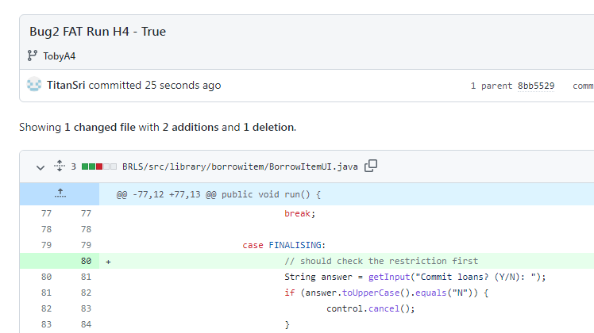

H5: Lbrary.canPatronBorrow(); is returning true all the time

T5: Inspect code for Lbrary.canPatronBorrow();

R5: patron.getNumberOfCurrentLoans() == LOAN_LIMIT; line 155 should be => equal or more than

H5: True

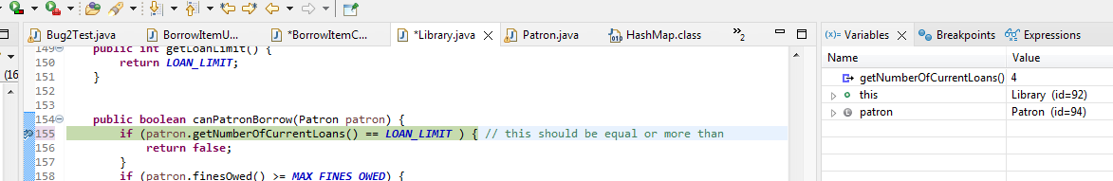

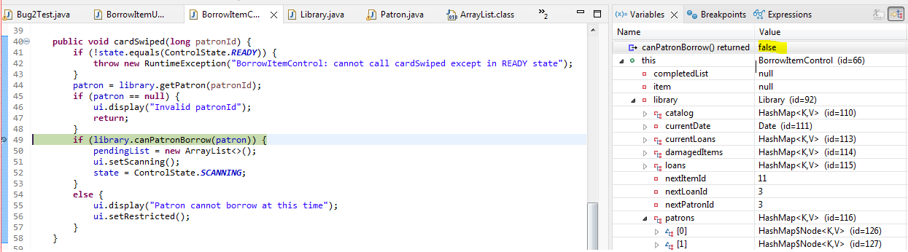

Commit logs:

<https://github.com/TitanSri/ITC205---A4/commit/9d59c4ee14034535a612017dc588554186cdab17>

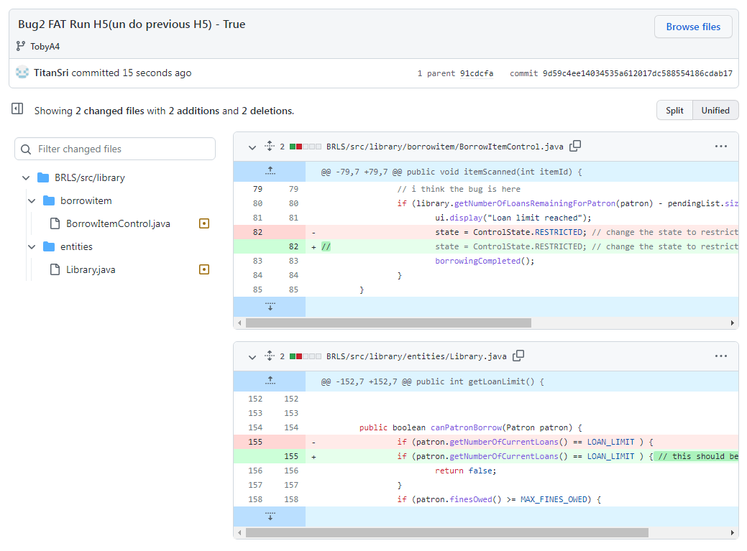

**Resolution**

H6: Lbrary.canPatronBorrow() changed to more than equals to line 155

T6: Inspect the code for Lbrary.canPatronBorrow()

R6: Change code **if** (patron.getNumberOfCurrentLoans() >= ***LOAN_LIMIT*** ) { in line 155

H6: True

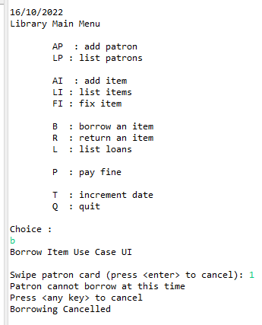

Commit logs:

<https://github.com/TitanSri/ITC205---A4/commit/a5c7a0eef7c5c39e6c8b93a806481e1f3e33db48>

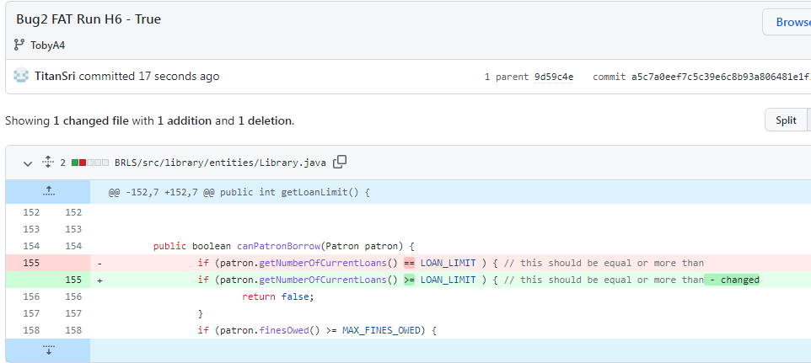

H7: BorrowItemControl.itemScanned() changed to less than equals to line 80

T7: Inspect the code for BorrowItemControl.itemScanned()

R7: Change code **if** (library.getNumberOfLoansRemainingForPatron(patron) - pendingList.size() <= 0) { in line 155

H7: True

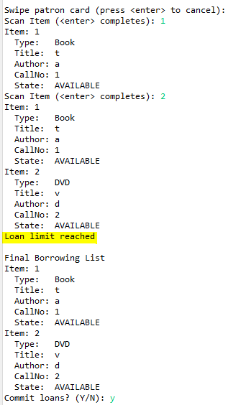

Commit logs:

<https://github.com/TitanSri/ITC205---A4/commit/922212ef3ef98159796b523327f2b23b50c5f3cd>

